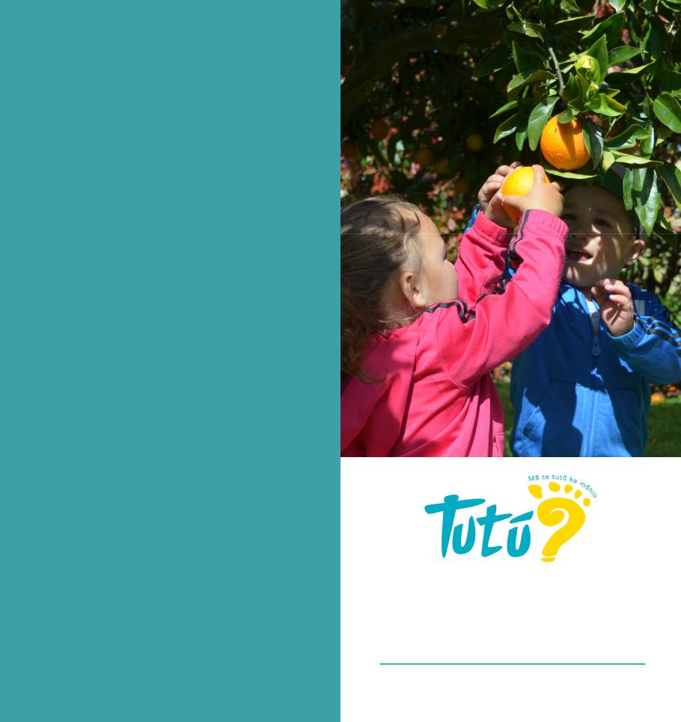

**OUR PHILOSOPHY**

Tutū will provide children and Educators with rich learning experiences in a safe learning environment upholding “Mā te tutū, ka mōhio”.

We recognise the unique abilities of each child and Educator for whom equal opportunities will be provided.

We uphold the principles of Te Tiriti Ō Waitangi and embrace Māori as tangata whenua of Aotearoa. Te Reo Māori is embedded throughout practice encapsulating whānaungatanga, kotahitanga, manaakitanga and akoranga.

**6.30am to 10.00pm – 7 days a week Licence**

**Whānau educating whānau**

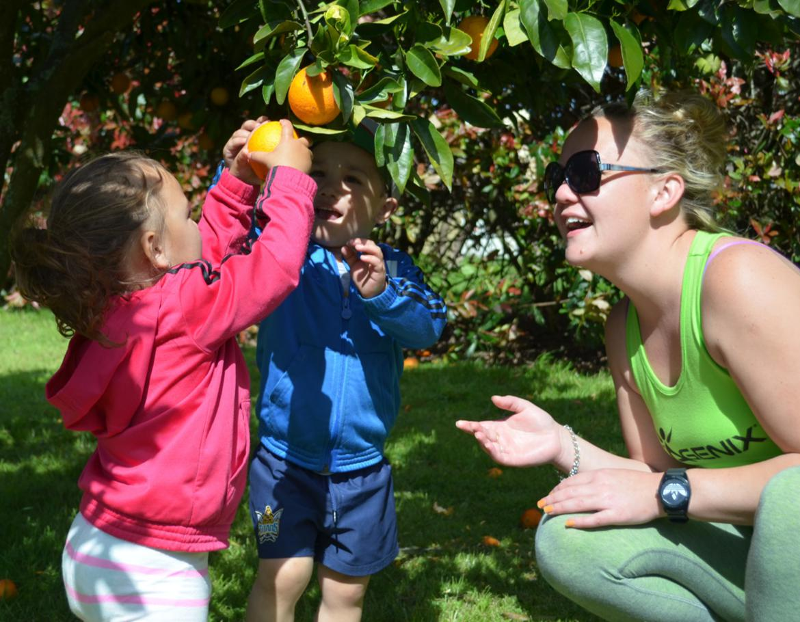

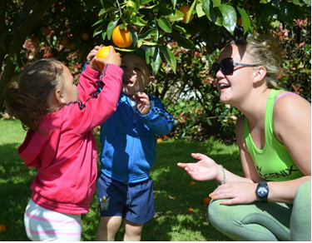

**CONTACT US**

To find out more about our services and fees structure please contact . . .

|  |  |  |
| --- | --- | --- |
| **Waea pūkoro** | | 0800 843 888 |
| **Waea** |  | 07 571 5539 |
| **Waea whakaahua** | | 07 571 8745 |
|  |  | |
|  | 022 107 9844 | |
|  | 022 327 3028 | |
| admin@tutuchildcare.co.nz | | |

**Find us on Facebook**

@TutuHomeBasedEarlyChildhoodEducation

**Visit our website**

tutuchildcare.co.nz

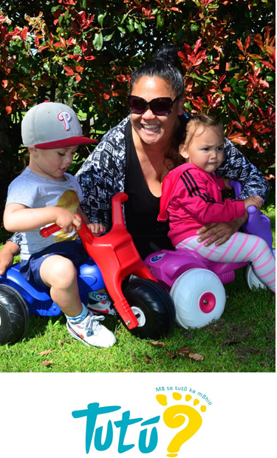

**EDUCATORS**

**Home-based Early Childhood Education**



tutuchildcare.co.nz

|  |  |  |
| --- | --- | --- |
| **ABOUT US**  Tutū Educators focus on providing holistic education and care for children up to five years old in a loving home environment.  We incorporate Tikanga, Kaupapa, and Te Reo Māori in everything that we do ensuring a safe, fun and secure learning opportunity for your tamariki.  Contact us to see how our service could be free. |  | **“Our tamariki are a taonga which I am helping to discover the world and learn new things. They are energetic, creative, passionate and boisterous beings, who are bursting at the seams to learn new things. I love being around them, I love watching them grow, I love seeing them learn, and most of all love that every day is a new adventure.”**  **Awhina Nuku, Educator** |





**WOULD YOU LIKE TO BECOME A TUTŪ EDUCATOR?**

|  |  |
| --- | --- |
| **Tēnā koutou katoa.** Are you 17 years or older? Do you already have children in your care, | |
|
| or would you like to care for children under 6 years in your own home? Would you like to | |
| work from home, setting your own hours and daily plan? |  |

|  |
| --- |
| **What is expected of Educators** |
|
| ·· To provide a safe learning environment that |
| encourages learning through play. |
| ·· To be experienced and passionate about working with |
| children and their whānau. |  |
| ·· To be warm, caring and friendly, and to have a sense |
| of humour. |  |
| ·· To participate in gatherings with other Tutū Educators |
|
| in order to build knowledge, understanding and |
| alternative theories. |  |
| ·· Current police vet check for all adults in the home |
| environment. |  |

**20 hours ECE funding is available for ALL 3 and 4 year old tamariki**

|  |
| --- |
| **We offer** |
|
| ·· On-going professional development and |
|
| opportunities to support your growth as an Educator. |
| ·· FREE play groups |
| ·· On-going support from qualified early childhood |
| teachers. |
| ·· FREE toy library |
| **Benefits of becoming an Educator** |
| ·· Competitive rates. Ask about our Tutū hourly incentive. |
| ·· Small group interactions – no more than four children |
| at any one time. |