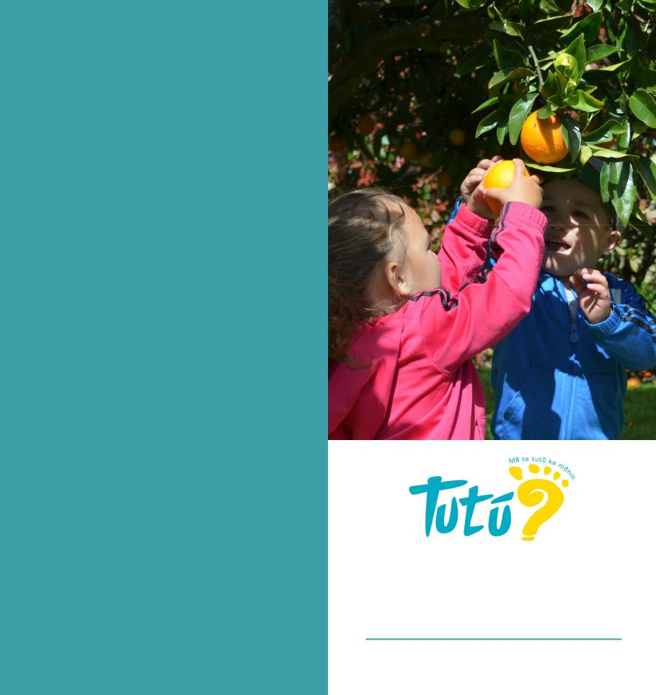

**WE VALUE OUR**

**WHĀNAU**

We invite all parents and caregivers to join us on our quest to provide your tamariki with the freedom to learn through play, in a safe and secure home environment.

We welcome and encourage you to participate through sharing what’s happening for your child at home in our daily journals; kōrero Māori ki tō kainga; attending our workshops or parent evenings; or joining our local community events.

Our bi-annual parent/caregiver surveys help us to ensure we are catering to the needs of our tamariki and whānau who are using our service. However, we also nurture an open friendly environment with all our whānau and Educators. We readily encourage conversation to support your needs, concerns or requests as they happen.

**6.30am to 10.00pm – 7 days a week Licence**

**Whānau educating whānau**

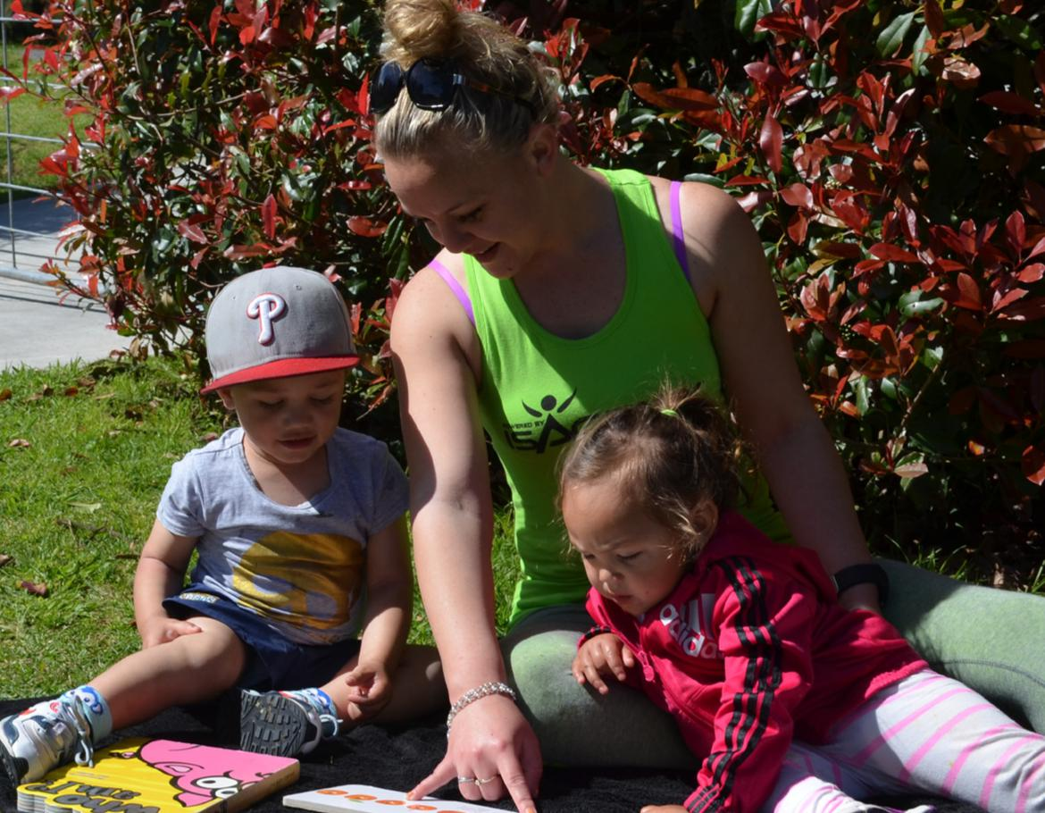

**CONTACT US**

To find out more about our services and fees structure please contact . . .

|  |  |  |
| --- | --- | --- |
| **Waea pūkoro** | | 0800 843 888 |
| **Waea** |  | 07 571 5539 |
| **Waea whakaahua** | | 07 571 8745 |
|  |  | |
|  | 022 107 9844 | |
|  | 022 327 3028 | |
| admin@tutuchildcare.co.nz | | |

**Find us on Facebook**

@TutuHomeBasedEarlyChildhoodEducation

**Visit our website**

tutuchildcare.co.nz

**WHĀNAU**

**Home-based Early Childhood Education**

tutuchildcare.co.nz

|  |  |  |
| --- | --- | --- |
| **ABOUT US**  Tutū Educators focus on providing holistic education and care for children up to five years old in a loving home environment.  We incorporate Tikanga, Kaupapa, and Te Reo Māori in everything that we do ensuring a safe, fun and secure learning opportunity for your tamariki.  Contact us to see how our service could be free. |  | **“My children have been in Tutū for almost 5yrs. Tutū’s flexibility to work in with my family’s needs, the low fee structure, and quality personal service is what attracted me to their service. Tutū strives to provide caregivers that meet the family’s needs. My caregiver is excellent, providing care to my children as if they were her own. I highly recommend you put your children in to the trusted care of Tutū, and watch them thrive.**  **Hannah Jones, Parent** |

**TUTŪ HOME-BASED EARLY**

**CHILDHOOD EDUCATION**

 **We offer a high quality, home-based early childhood education service**

**for you and your tamariki.**

**20 hours ECE funding is available for ALL 3 and 4 year old tamariki**

**Our Vision**

Tutū is an Early Childhood Home-based Service that nurtures and supports holistic learning

by embracing positive relationships while upholding whānau and cultural values to provide

a platform that inspires and nurtures learning.

**We offer Philosophy**

Tutū will provide children and

··Fun and loving home environment

··Advice, guidance and support

··FREE playgroups

··FREE toy library

··FREE weekly excursions to local activities

Your child will have the opportunity to build confidence

and social skills through the interaction with other children in their group, as well as at our play group gatherings.

Educators with rich learning experiences

in a safe learning environment upholding “Mā te tutū,

ka mōhio”. We recognise the unique abilities of each

child and Educator for whom equal opportunities will be provided.

We uphold the principles of Te Tiriti Ō Waitangi and

embrace Māori as tangata whenua of Aotearoa. Te Reo

Māori is embedded throughout practice encapsulating whānaungatanga, kotahitanga, manaakitanga and

akoranga.

·